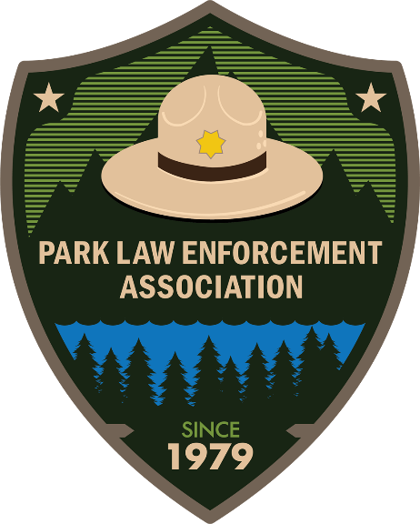

**PLEA Annual Training Conference**

**February 25-27, 2020**

**DeGray Lake Resort State Park**

**Agenda**

**Sunday, February 23**

Golf for early arrivals. Available all day. Please RSVP with Brad DePriest at Brad.DePriest@arkansas.gov.

3:00 PM - Eagle Tour via boat on DeGray Lake for early arrivals.

**Monday, February 24**

9AM – 3PM – Board of Directors Meeting – PLEA Executive Board and Board Members. Open to all PLEA members.

9am-7pm – Vendor Setup in Lobby Area. Check-in with Arkansas State park Staff.

Golf for early arrivals. Available all day. Please RSVP with Brad DePriest at Brad.DePriest@arkansas.gov.

3:00 PM – Eagle tour via boat on DeGray Lake for early arrivals.

4-7:00 PM – Registration in DeGray Lake Resort State Park Lodge Lobby.

6-10 PM – Networking Social – Lobby - Sponsored by Spartan Mowers

**Tuesday, February 25**

6:30 AM -7:45 AM- Breakfast

7:00 AM -7:45 AM – Registration and Meet & Greet – Lobby.

8:00 AM – **Opening Ceremonies.** **Welcome by PLEA President and Host Agency.**  
Colors and pledge by the Arkansas Game & Fish Commission Honor Guard - Caddo Room.

8:30 AM – 9:30 AM –**What to do when things don’t go as planned.** – Arkansas State Parks Director Grady Spann.

9:30 AM – Morning Break – Sponsored by the University of Arkansas at Fort Smith

10:00 AM – 12:00 PM – **Drone Technology/AGFC Special Operations** - Brian Aston & Steve Paul.

12:00 PM – 1:00 PM - Lunch (On your own)

1:00 PM - **Hog Depredation Management Planning and Strategies** – Paul Butler, Superintendent Moro Bay State Park.

3:00PM – Afternoon Break

3:15 PM - 5:00 PM –**Search and Rescue Planning and Implementation for Successful Outcomes** Stewart Carlton, Superintendent Toltec Mounds Archeological State Park.

5:00 PM – 10:00 PM – Networking Social – Lobby – Sponsored by Unmanned Vehicle Technologies

**Wednesday, February 26**

6:30 a.m. - 7:45- Breakfast, Shoreline Restaurant (on your own).

8:00 AM Meet outside the lobby for bus transportation. Please be on time as we have a tight schedule to keep.

9:00 AM – Arrive at **Historic Washington** for Trial by Jury.

11:30 AM – 12:30 PM – Lunch Provided.

12:45 PM – Depart for Crater of Diamonds State Park. **The only public diamond mine in the world!**

1:30 PM – Arrive at the Crater of Diamonds State Park and mine for diamonds. Yes, mine for diamonds that you can take home. Bring an extra pair of boots.

4:00 PM – Depart for DeGray Lake Resort State Park.

5:00 PM – Arrive at DeGray Lake Resort State Park.

6:30 PM -8:30 PM – **Awards Banquet** – DEGRAY ROOM. Dinner is provided.

8:30 PM – 10:00 PM – Networking Social – Lobby – Sponsored by Spartan Mowers

**Thursday, February 27**

6:30 AM -7:45 AM -Breakfast (Shoreline Restaurant) – On your own.

8:00AM – **Lt.** **Colonel Dave Grossman – Bulletproof Mind**

10:00 AM – Break – Sponsored by Arkansas Tech University

10:15 AM – **Lt.** **Colonel Dave Grossman – Bulletproof Mind**

12:00 PM - 1:15 PM - Lunch (on your own)

1:15 PM – **Lt.** **Colonel Dave Grossman – Bulletproof Mind**

3:00 PM – Break

3:15 PM – 5:00 PM – **Lt.** **Colonel Dave Grossman – Bulletproof Mind**

5:30 PM – 10:00 PM – Networking Social – Lobby – Sponsored by Unmanned Vehicle Technologies

**Friday, February 28**

6:30 a.m. -8:00 a.m. - Breakfast

11AM Checkout

**Speaker Spotlight:**

**Grady Spann**

**Parks Director – Arkansas State Parks**

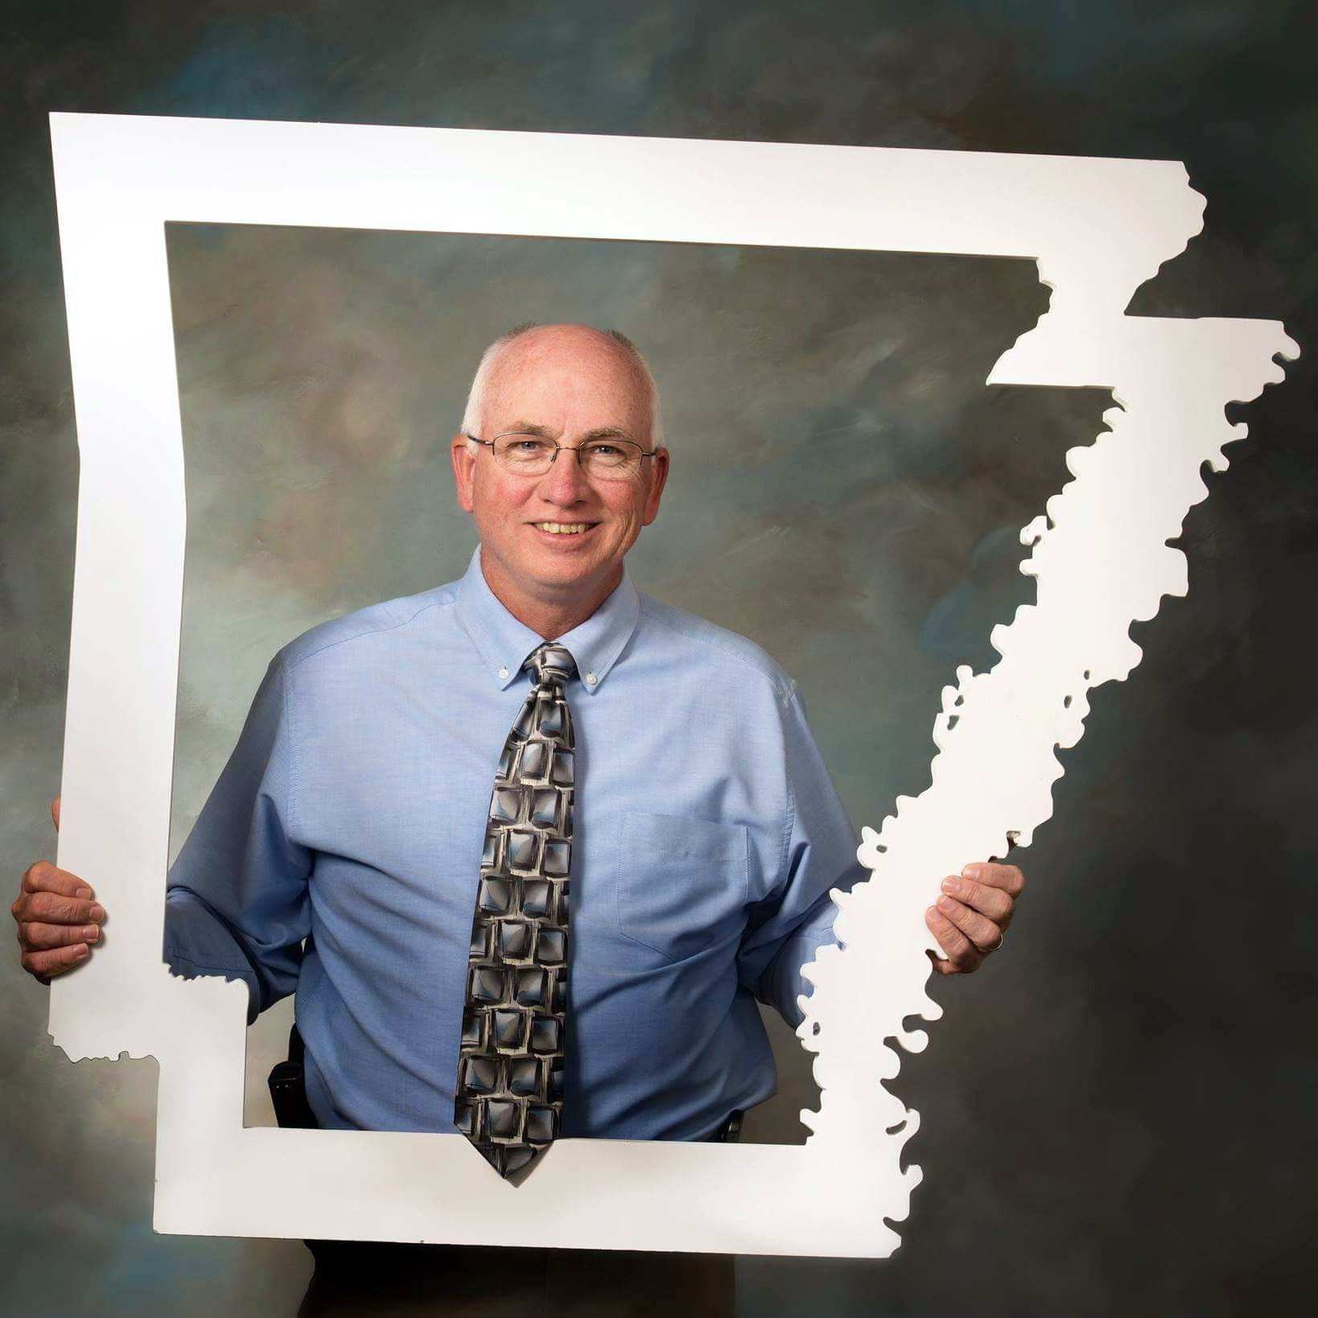

Grady Spann joined Arkansas State Parks in 1993 as the superintendent of Parkin Archeological State Park. In 2002, after nine years at Parkin, he transferred to Historic Washington State Park to serve as the superintendent. In 2005 he transferred to the Ozark Folk Center State Park where he served as the Park Superintendent until 2012. After seven years at the Ozark Folk Center, Grady was promoted to serve as the Region 5 Supervisor, a newly created region that oversees all lodge parks. In 2016, Grady was promoted to Director of Arkansas State Parks. Grady also serves as a park ranger after graduating from the Arkansas Law Enforcement Training Academy in 1995.

Prior to working for Arkansas State Parks, he served in the U.S. Army for nine years as a military tactical intelligence and counterintelligence officer. He was stationed at Fort Huachuca, Arizona; Fort Polk, Louisiana; Rio de Janeiro, Brazil; and in Washington D.C. He has been awarded the Meritorious Service Medal, Army Commendation Medal, Army Achievement Medal, National Defense Ribbon, Army Service Ribbon, Overseas Service Ribbon and the Pacifist Medal from the Brazilian Army.

He graduated from Henderson State University in 1984 with a Bachelor’s of Science in parks administration and a minor in military science.

Grady is currently on the board of directors for the National Association of State Park Directors (NASPD), President of the Association of Southeast State Park Directors and on the Chairman of the Board of Regents for the NASPD State Park Leadership School. He has served on several state boards of directors including - Ozark Gateway Tourism Association, Delta Byways Tourism Association and serving as president for five years, the Arkansas Craft School, the Arkansas Baptist Bikers Association, Bikers for Babies, and the Arkansas Bikers for Children, he is the former chairman of Mountains, Music and Motorcycles - a bike rally sponsored by the Mountain View Chamber of Commerce.

Grady grew up in Recife, Brazil where his parents served as missionaries for 33 years. He is fluent in Portuguese. Grady’s hobbies include mountain biking, motorcycle tourism, soccer, surfing, and spending a lot of time with his family. He is married and has five children ranging in age from 19-33.

**Course Description:**

**What to do when things don’t go as planned** – This presentation is a case study on an event that occurred at War Memorial Stadium in 2018 when a mass evacuation occurred from the stadium as a result of a perceived threat.  What do you do when 38,000 people go into a panic and how do you regain control of the situation and re-establish trust within your community.  This event has resulted in better planning and a better understanding on how to prepare for the security of large events and how to effectively react to a situation that could happen at any venue.

**Brian Aston**

Lieutenant Arkansas Game & Fish Commission

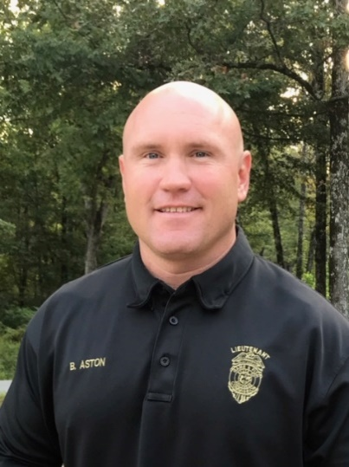

Lieutenant Brian Aston oversees the Arkansas Game and Fish Commission (AGFC) Special Operations Teams which include: K-9 unit, Dive Team, Honor Guard, Disaster Response Team, Special Investigative Unit, Chaplain, Marijuana Eradication, and the UAS program. Lt. Aston has worked for the AGFC for 17 years and is assigned to the AGFC HC Red Morris Training Center at Mayflower Arkansas. He is married to his lovely wife of 16 years, Emily. They have two children, Dylan who is 13 and Briley who is 8.

**Steve Paul**

Sergeant Arkansas Game & Fish Commission

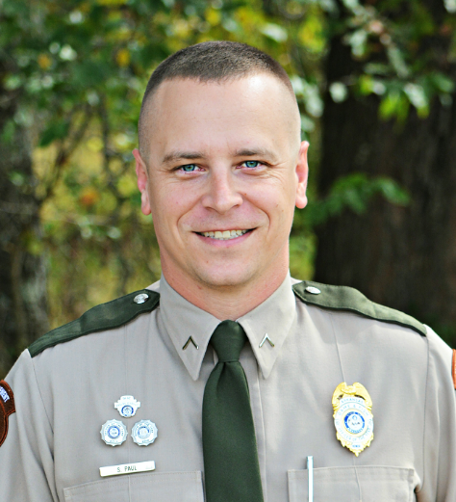

Sergeant Steve Paul assists Lieutenant Aston in overseeing the Arkansas Game and Fish Commission (AGFC) Special Operations Teams which include: K-9 Unit, Dive Team, Disaster Response Team, Special Investigative Unit, Chaplain, Marijuana Eradication, and the UAS program. Sgt. Paul has worked for the AGFC for 9 years and is assigned to the Arkansas Game and Fish Commission Headquarters Office in Little Rock, Arkansas. Before coming to work for the AGFC, Sgt. Paul spent 6 years for working for Arkansas State Parks. He has been married to his lovely wife Jennifer for 7 years. They have three children, Logan 15, Ramsey 12 and Finley Joe 5.

**Course Description:**

**Drone Technology/AGFC Special Operations**

The AGFC Unmanned Aircraft System (UAS) purpose is to provide aerial support during searches for missing persons (SAR missions), scene assessment during natural or man-made disasters, boating accident investigations, hunting accident investigations, and for officer safety while locating / apprehend fleeing felons. The UAS program also serves as support unit for all AGFC special operations groups including the Dive team, K-9 Unit, and the Special Investigative Unit.

**Paul Butler**

Park Superintendent, Moro Bay State Park

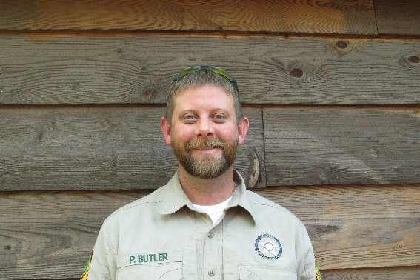

Paul is the Park Superintendent of Moro Bay State Park in South Arkansas.  This small but well used park in South Arkansas is located on the lower Ouachita River where 3 waterways meet.  It is one of the most popular summer recreation areas within several counties. In 2010, Paul completed the state’s Law Enforcement Training Academy (finished in the top 10 in shooting accuracy, studies, and physical test) and since then has served as the parks only commissioned law enforcement officer.  The park has a full-service campground, fully furnished cabins, a park store, a full-service marina, and a relatively busy day use area.  Paul has managed the park for the last 10 years of his 14-yr. career with Arkansas State Parks.  Paul graduated with honors from the University of Arkansas at Monticello with a Bachelor of Science in Wildlife Management while also playing left field for the school’s baseball team.  He has served for the last 2 yrs. on the Governors Feral Hog Task Force at the request of the Parks Director (along with the department’s chief ranger) for the Department of Parks and Tourism.  In addition to serving on serval other boards and committees, (plus a couple special recognitions/ directors accommodations from within the Department), some of Paul’s career achievements include: Being named Bradley County Citizen of the year in 2012, his park received an award in 2015 for Best Practices in Resource Management under his leadership, he Graduated from the National State Park Leadership School in 2017 in Wheeling West Virginia, and in 2018 his park was named regional park of the year missing the overall award by one vote.  Paul is a highly involved church member of a bible-based church, a husband, a father of two girls, and an avid outdoorsman.  He believes in loving others, treating people the way he wants to be treated, doing your best at everything you do, and leadership by example

**Course description:**

**Hog Depredation Management Planning and Strategies**

In this 2-hour block, you will learn about the feral hog problem in Arkansas and see how Arkansas State Parks is being proactive to combat this destructive invasive species.  We will discuss and demonstrate the use of a smart trap; the most effective way to reduce the feral hog population in Arkansas.  Also we will share some of the challenging decisions involved in establishing your own feral hog program.

**Stewart Carlton**

Park Superintendent, Toltec Mounds Archeological State Park

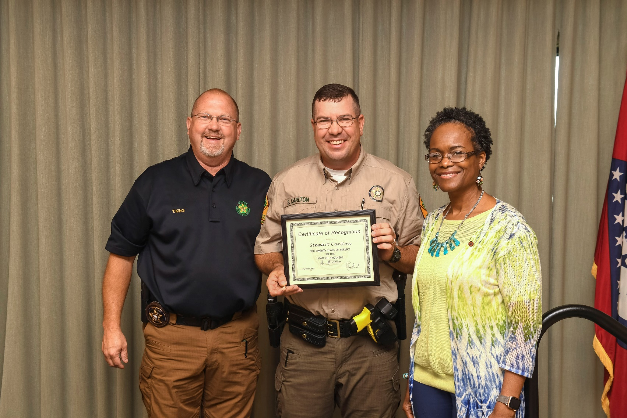

Stewart Carlton just completed his 20th year of service with Arkansas State Parks. In that time, he has served as Park Interpreter at Mount Nebo State Park (3 month seasonal), Petit Jean State Park (6 month seasonal), Parkin Archeological State Park, and Bull Shoals-White River State Park. In 2002, he graduated from the Arkansas Law Enforcement Training Academy and started his law enforcement, fire, emergency medical, and search and rescue duties as a Park Ranger at Petit Jean State Park. He has also served as the Assistant Superintendent at Pinnacle Mountain State Park and for the past 11 years has served as the Park Superintendent at Toltec Mounds Archeological State Park. Stewart has been a trained member of the Arkansas State Parks Search & Rescue Team since 2001 and holds National Association of Search and Rescue certifications in ISAR, FUNSAR, ADSAR, MLPI and is a SAR Tech II. Additionally, he is a certified NASAR instructor and evaluator. He is a certified law enforcement instructor, firearms instructor, and armorer. Stewart serves on the Arkansas State Parks Law Enforcement and Search & Rescue Committees. He is currently serving as the Team Leader on the Arkansas State Parks Region 2 Search and Rescue Team.

Stewart graduated with honors from Webster University in 2011 with a M.S. in Environmental Management. He is also a 1998 graduate of Arkansas Tech University where he earned a B.S. in Biology Education. Stewart is a graduate of the National Association of State Parks Directors Leadership School and the Arkansas State Parks Management Training Program.

Stewart is a 12-year veteran of the Arkansas Army National Guard and is married with two kids and two grandkids. He currently serves as the Assistant Scoutmaster for Boy Scout Troop 18 in North Little Rock, Arkansas. His favorite hobbies include mountain biking, fishing, hunting, hiking and backpacking.

**Course description:**

**Search and Rescue Planning and Implementation for Successful Outcomes**

In this presentation, you will gain insight on how Arkansas State Parks plans for and carries out search and rescue missions within its parks and neighboring communities. We will discuss various lessons learned, planning strategies, training strategies, and operations strategies that lead to successful outcomes. We will also discuss what to do when things don’t go as planned!

**Dave Grossman**

Lt. Colonel, U.S. Army (ret.)

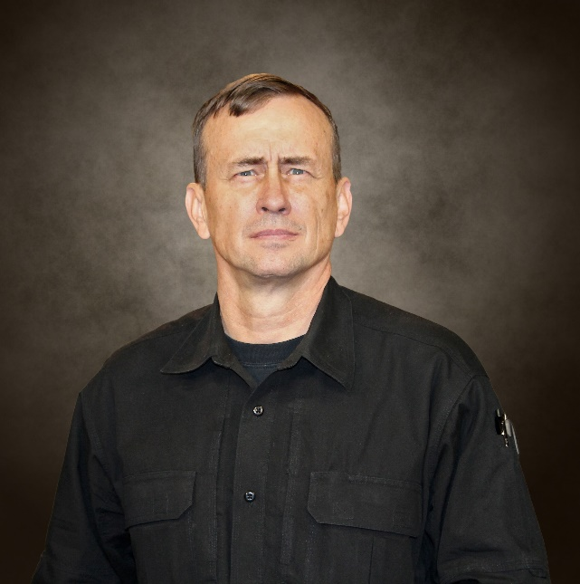

Dave Grossman Lt. Colonel, U.S. Army (ret.)

In their description of Lt. Col. Dave Grossman, Slate Magazine said, “Grossman cuts such a heroic, omni competent figure, he could have stepped out of a video game.” He has five patents to his name, has published four novels, two children’s books, and six non-fiction books to include his “perennial best seller” On Killing (with over half a million copies sold), and a New York Times best-selling book co-authored with Glenn Beck. He is a US Army Ranger, a paratrooper, and a former West Point Psychology Professor. He has a Black Belt in Hojutsu, the martial art of the firearm, and has been inducted into the USA Martial Arts Hall of Fame. Col. Grossman’s research was cited by the President of the United States in a national address, and he has testified before the U.S. Senate, the U.S. Congress, and numerous state legislatures. He has served as an expert witness and consultant in state and Federal courts. He helped train mental health professionals after the Jonesboro school massacre, and he was also involved in counseling or court cases in the aftermath of the Paducah, Springfield, Littleton and Nickel Mines Amish school massacres.

(revised 1/9/2020)